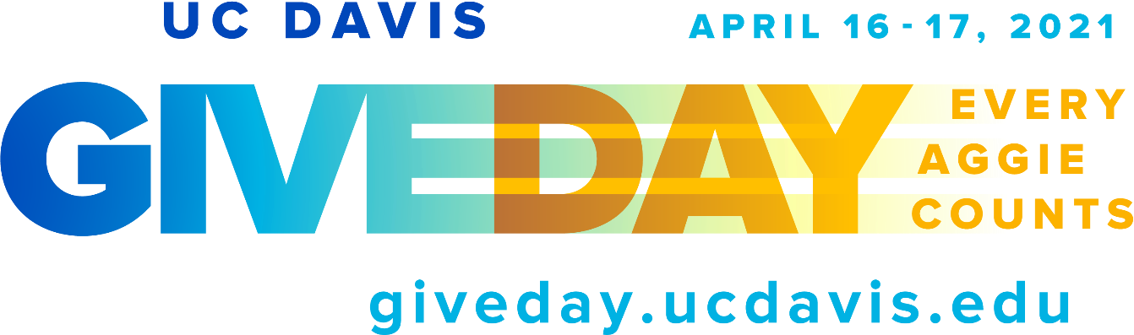  Give Day 2021 Social Media Toolkit | For more information on UC Davis Give Day please contact:  Director of Marketing and Communications, ASGP  Andrea Elliott ahelliott@ucdavis.edu  Sr. Director of Annual and Special Gifts (ASGP), Michelle Poesy mlpoesy@ucdavis.edu

Thank you for being a social ambassador!
Thank you for supporting UC Davis Give Day! In this toolkit you will find many images from UC Davis and UC Davis Health you can use in your own social media posts.
Remember to include the hashtags #UCDavisGiveDay, #EveryAggieCounts and #UCDHstrong in your posts, so they can be automatically be pulled onto the main Give Day site during our 29-hour Give Day event. Please keep in mind your personal social media settings may restrict your posts from showing up on the Give Day site.
Please also check out UC Davis GIF’s: https://giphy.com/UCDAVIS
Update your Profile Photo
Click the pictures below, then right-click the picture and save it to your computer or hold down on the photo to save to your phone. Post the picture as your Facebook profile photo with a caption including the hashtags mentioned above. Also, include a link back either to the Give Day page (giveday.ucdavis.edu) or to an individual college, school, unit or fund page.
Post a video message or photo
Posts with photos or videos are more likely to be clicked on. Here are some guidelines:
Video - Challenge your network to give during UC Davis Give Day with a video message! Post it using the hashtags noted above. Also include a link back to either the Give Day page (giveday.ucdavis.edu) or to an individual college, school, unit or fund page.
Photo - Click the thumbnail below, then right-click the picture and save it to your computer, or hold down on the photo to save to your phone.
To include a link back to either the Give Day page (giveday.ucdavis.edu) or to an individual college, school, unit or fund Give Day page, just copy the web address out of the top address bar and include it in your social media posts. For example, if you feel passionate about the College of Engineering, you would link to https://giveday.ucdavis.edu/giving-day/34890/department/34891
Create a post
To create any post, just tell a brief story that conveys why you support what you support at UC Davis and include a link to the challenge or the page you want people to support. Tell people very briefly the impact they will have if they support the program and how their gift will make a difference. Consider telling a brief personal story how the program impacted you, and how you think it will make a difference for others.

Social media cover images
Cover images for Facebook, Twitter and LinkedIn have been formatted specifically to fit the dimension of each service’s cover image.
Do not use interchangeably: using a graphic formatted for one service as the cover image on an alternate service will have an undesirable outcome.
Facebook:
Twitter:

LinkedIn:

Social Media graphic posts
Ready-to-use graphics:
